

**Course Information**

Course Title: Digital Image Processing

Section: 1

Course Instructor: Dr. Ahmed Wasif Reza

Associate Professor

Department of Computer Science & Engineering

**Lab-04**

**Student’s Information**

**Name:** Mujahidul Islam

**ID:** 2019-2-60-072

**Department:** Computer Science & Engineering

**Date of Submission: 17 November 2022**

**Question 1**

Sharpen the following image by applying the following:

**Unsharp Masking**

Code:

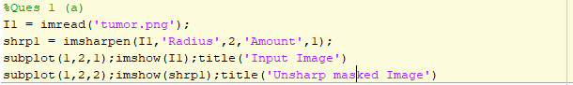

Output:

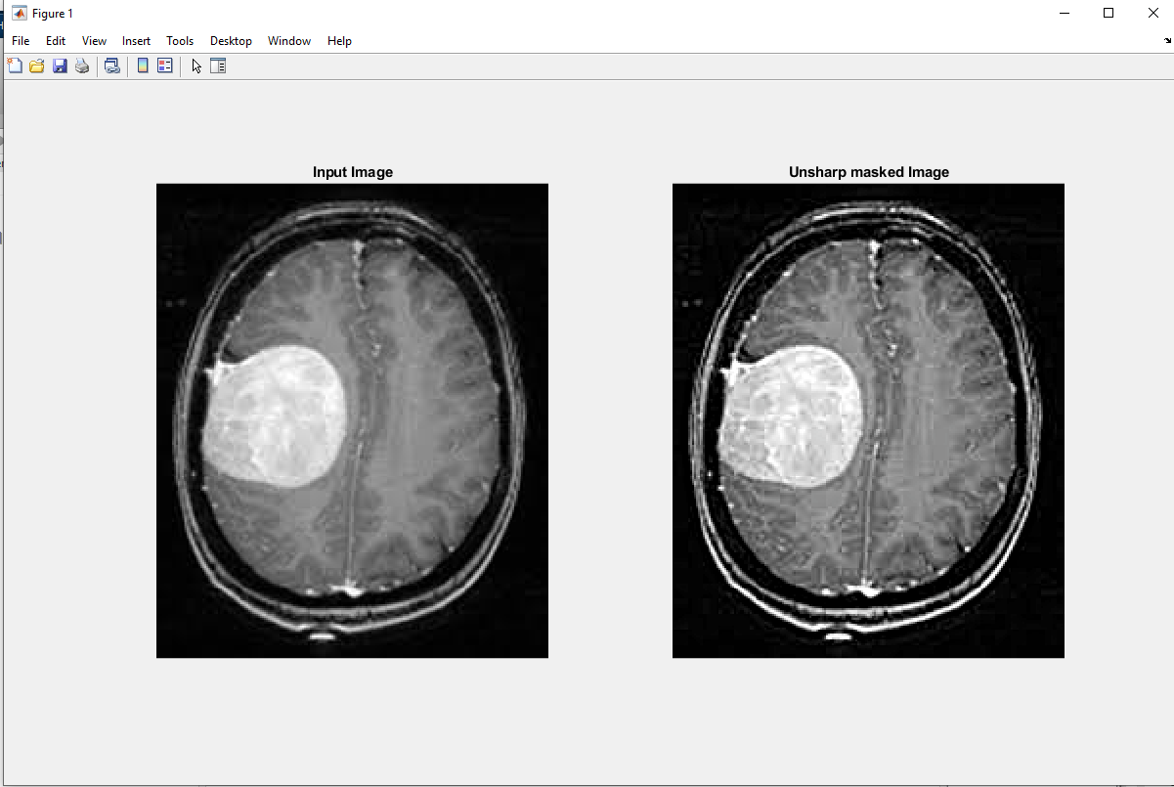

**High Boost Filtering**

Code:

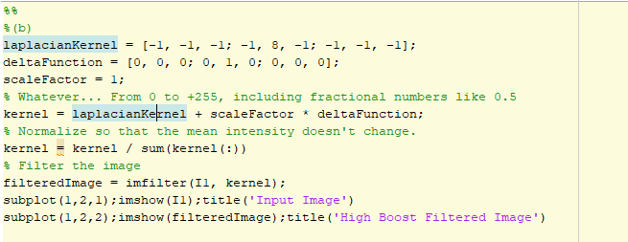

Output:

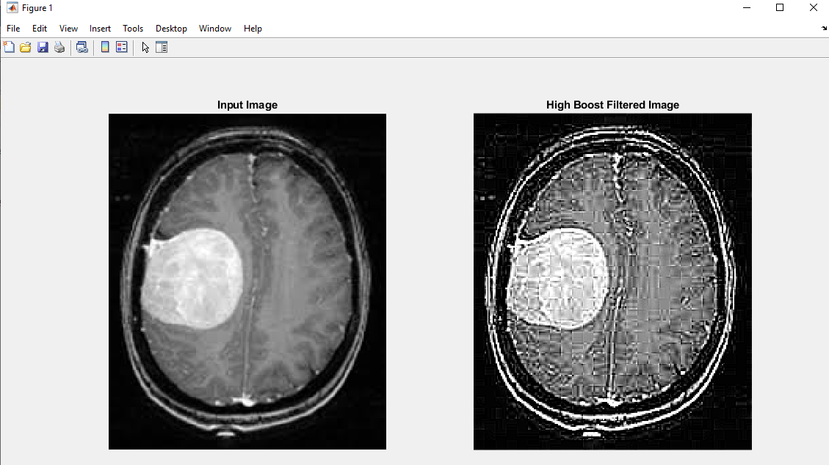

**Question 2**

Sharpen the following image using the concept of **Laplacian Filtering**.

Code:

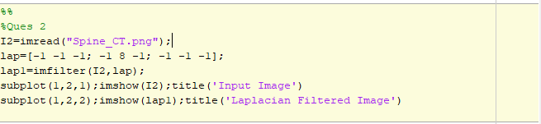

Output:

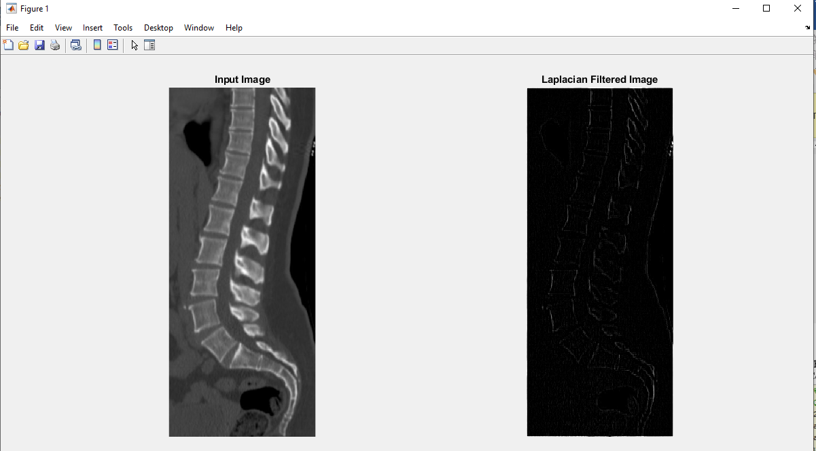

**Question 3**

Use **Roberts-cross** operators to detect the edge of the following image.

Code:

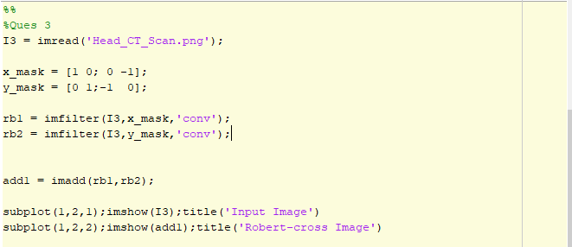

Output:

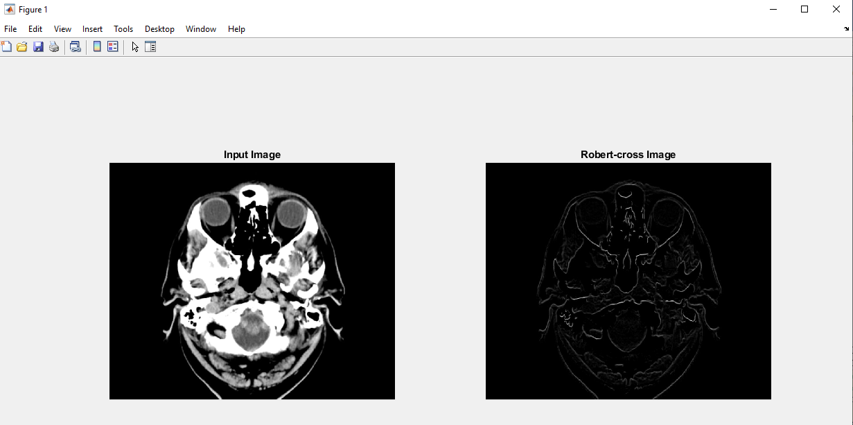

**Question 4**

Use **Sobel** operators to detect the edge of the image from problem 3.

Code:

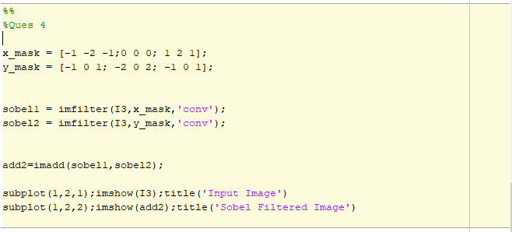

Output:

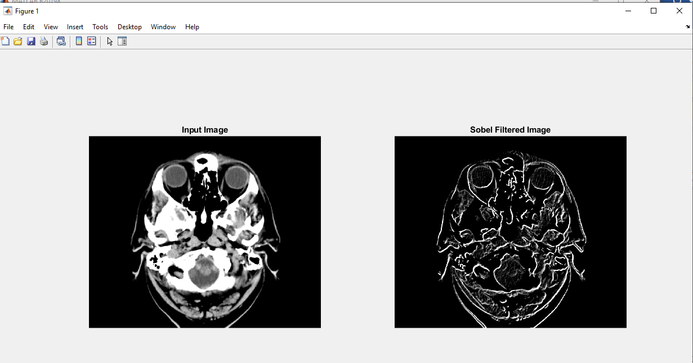

**Question 5**

Use **Prewitt** operators to detect the edge of the image from problem 3.

Code:

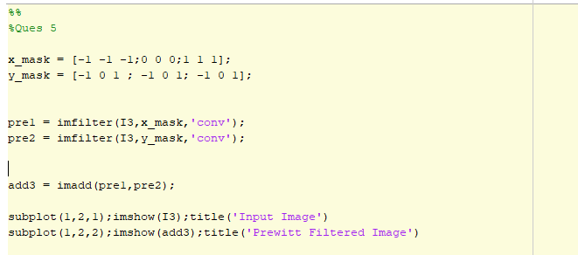

Output:

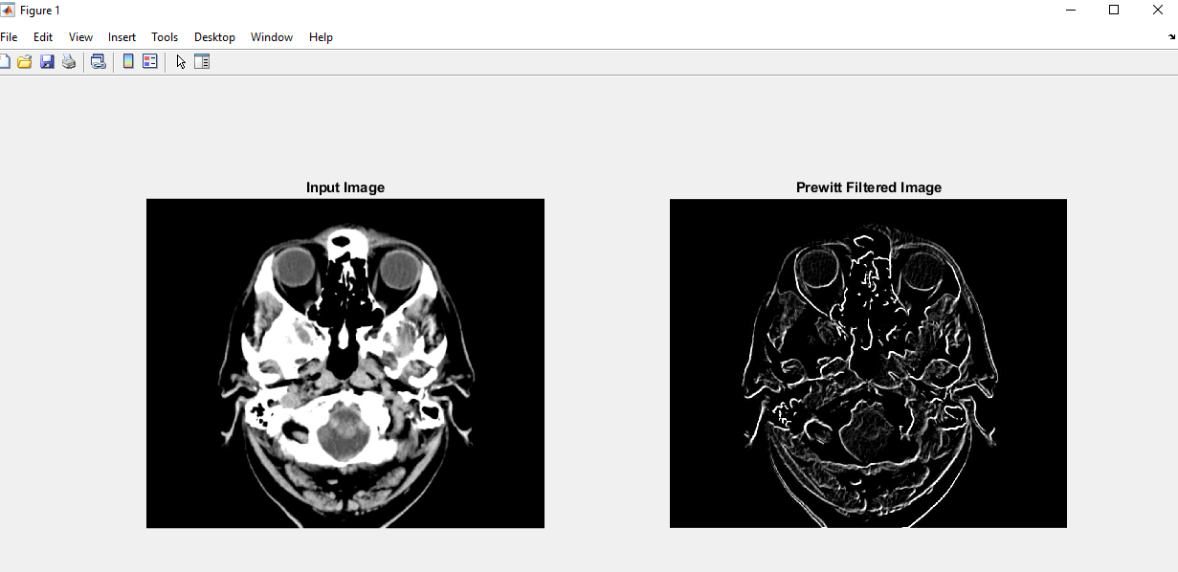

**Question 6**

Show performance comparison among High Boost, Unsharp, Laplacian Roberts-cross, Sobel and Prewitt filtering for edge detection – find out which one is better for the given images.

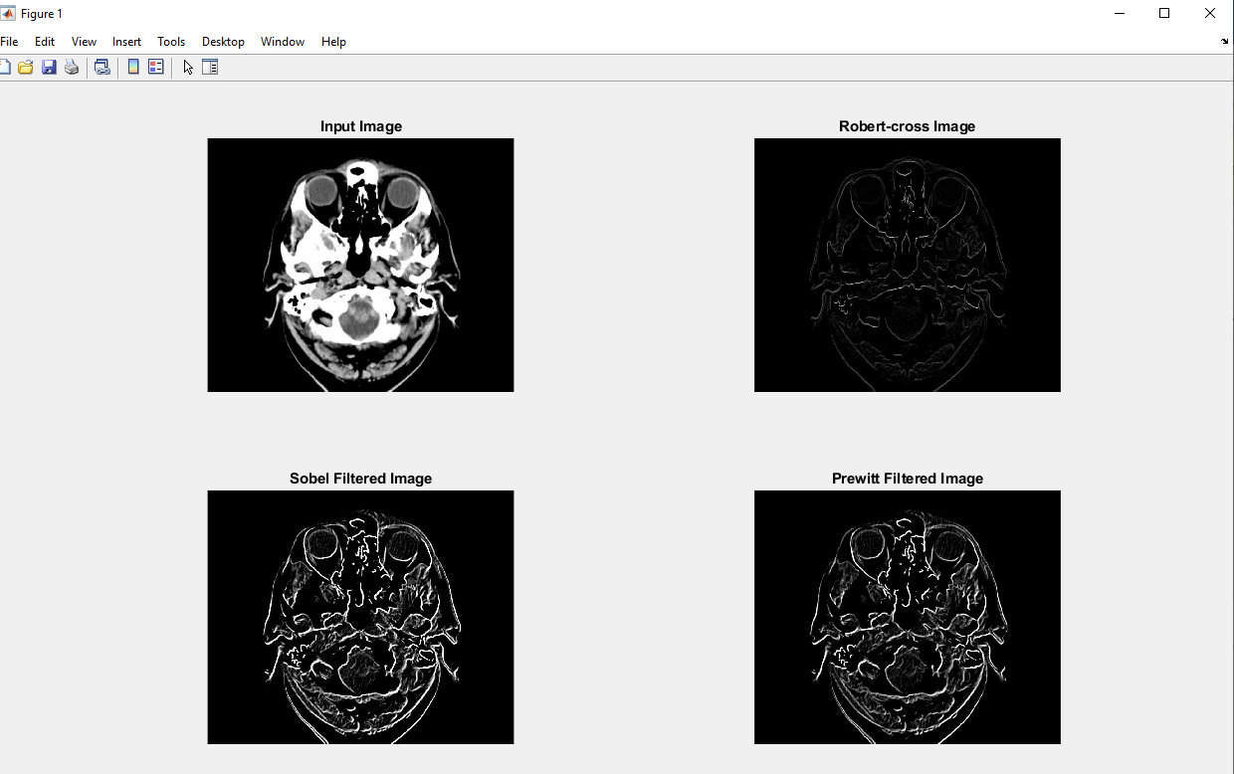

As we can see from the output, if we want to extract edge than from my point of view Prewitt operator works better. Because it not only highlights the edges but also smoothen the inner area. It is a useful for better object detection.